

***IR Protocol***

Bluetood controlled car and IR

CRistian Lopez and Kevin Lopez

2019

# **Table of Contents**

1. Table of figures
2. Introduction
3. Operation
4. Hardware
   1. Hardware Block Diagram
      1. IR Transmitter Station
      2. IR Receiver Station Flowchart
   2. Schematic
      1. IR Transmitter Station
      2. IR Receiver Station Flowchart
   3. Components list
   4. Explanation
5. Software
   1. Approach
   2. Software flow diagram
      1. IR Transmitter Station
      2. IR Receiver Station Flowchart
6. Waveforms
   1. IR Waveforms
   2. Bluetooth set up
7. Conclusion

# **Table of Figures**

1. Block Diagram
2. Schematic

2.1 Bluetooth Controlled Car 2.2 Receiver Station & 8-bit DAC

1. Software Flow Diagram

3.1 IR Transmitter Station

3.2 IR Receiver Station

# **Introduction**

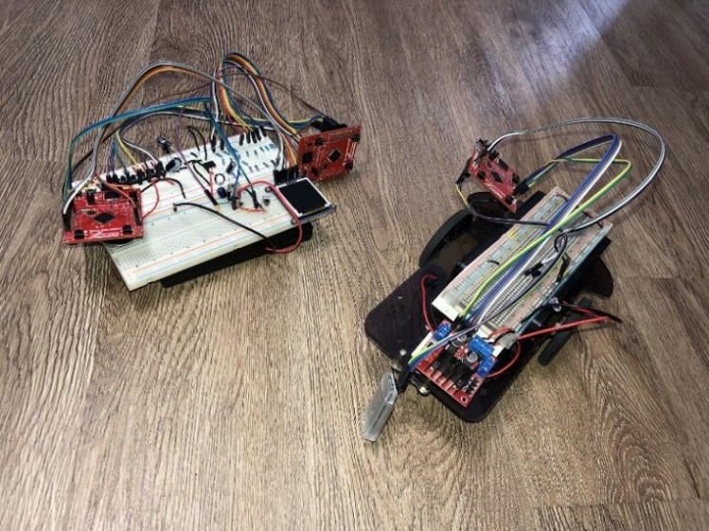 The objective of this project was to create our own IR protocol integrated with a Bluetooth module on a TM4C launchpad. The IR protocols works on a frequency between 38Khz and 40Khz and have a start bit signaling that a new command is being sent. This IR protocol works on a 40Khz frequency and has a 1.5ms start bit, two bits address, and followed by a four-bit Command. This IR protocol is being integrated to a Bluetooth car that transmits to a receiver station. It is composed of an LCD screen, a Digital to analog circuit and an IR receiver module. In the other side the infrared transmitter is composed of a remote-control car with a Bluetooth module, an IR transmitter and other components so there could be signals sent and be able to drive such car around.

# **Operations**

The car has two DC motors to move around and their speed was controlled using Pulse Width Modulation on each individual wheel. It also has ability to be controlled by Bluetooth then after being positioned to the designed station, we can send IR commands to trigger a specific animation or note coming from our 8-bit DAC. In order to be able to communicate with the IR protocol, we had to use PWM to generate a square wave at 40KHz, then this was controlled by a timer that would change depending if we wanted to transmit a logic 1 or a logic 0. Universal Asynchronous Receiver/Transmitter (UART) was also used in this project heavily to communicate with the HM-10(Bluetooth module) and the DAC created in the past project. Whenever the receiver station received a value that was between 5 and 12, the station would transmit the command to the DAC to play a specific note.

# **Hardware**

# *Car Hardware Block Diagram*

# 

# *Receiver Station Hardware Block Diagram*



# **Schematic**

## 2.1 Bluetooth Controlled Car

## 2.2 Receiver Station & 8-bit DAC

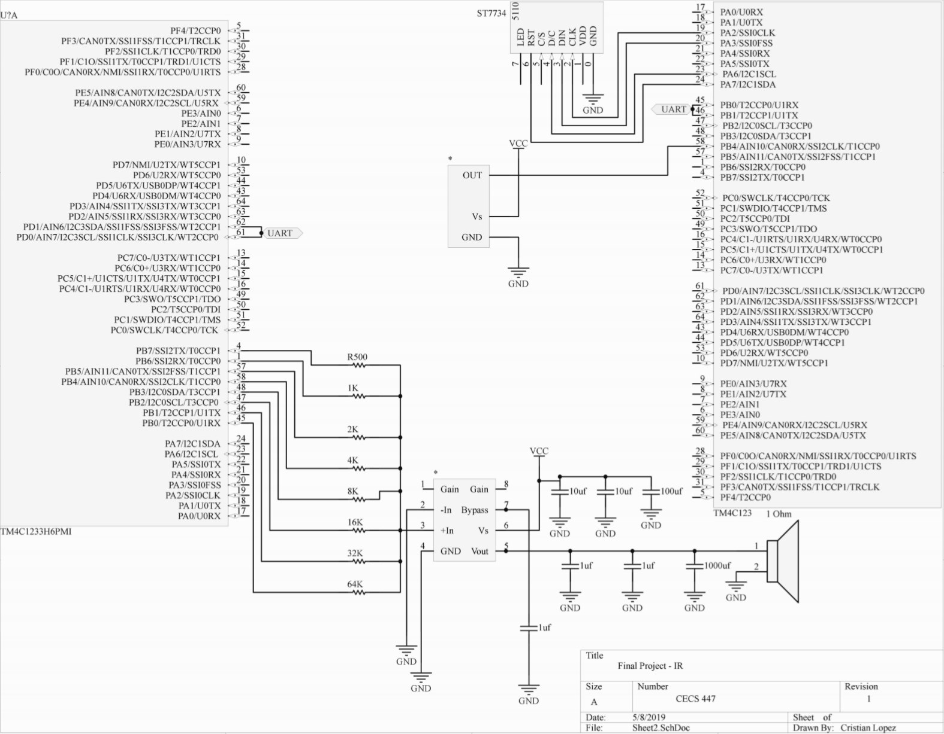

# List of Components

* 3 x TMC4C Launchpad
* HM-10
* EK8443 infrared Emitter led
* IR Receiver module (40Khz)
* Linear regulator (7805)
* ST778 LCD Display
* H-Bridge
* 2 x DC motors
* 12 x AA batteries
* Transistors
* LM386 Operational amplifier
* 1 Ohm Speaker is
* 500, 1k, 2k and up to 64k 1% tolerance resistors
* Buttons, wires, and capacitors
* Power supply, oscilloscope and Keil Uvision 4 for debugging

# *Hardware Explanation*

The whole project circulated around the IR protocol since was the new subject to learn for communication. For such protocol, an EK8443 infrared Emitter led is used hence the low cost. The car was controlled with a HM-10 module that was communicating via UART to a Tiva Launchpad MCU. This module was used since it has Bluetooth 4.0 and works with all Apple Devices. The MCU was programmed so that different ascii characters received would transmit an IR signal to the receiver station, we can see these characters in table below.

In the other side we had a receiving station composed of an IR receiver module and two TM4C123 launchpads communicating with each other via UART. One of the launchpads demodulates the IR signal and the other is used to control the Binary Weighted DAC. A 38Khz IR receiver is used since 38Khz is the most common frequency used for other devices.

# **Software**

# *Approach*

To achieve that goal, we used a HM10 Bluetooth module communicating to our TM4C by UART at a baud rate of 57600, 8 Data bits, 1 stop, and odd parity. Then to achieve the encoding of the IR protocol we used concepts of Pulse Width Modulation and timers. The PWM frequency was set to 40Khz and a timer was used to keep count for how long were sending an actual signal. The decoding also used the concepts of timers but in this case, we took advantage of the difference from a logic 1 and logic 0 which created a low to high level difference of 600 msec. We sampled around this area of time to see the bit we received.

# Software Flowchart

## IR Transmitter Station

# 

## IR Receiver Station



# **Waveforms**

*Address 0 Command 0*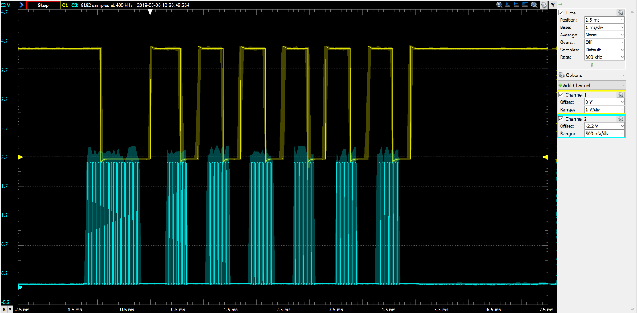

## *Address 0 Command 1*

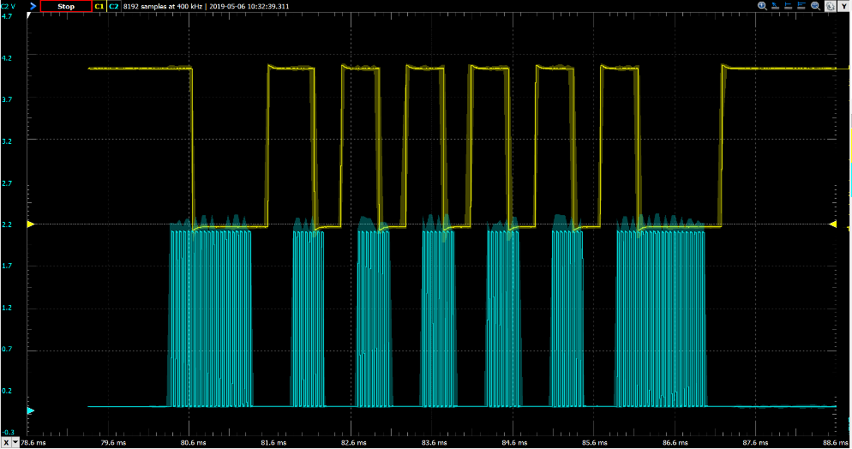

## *Address 0 Command 2*

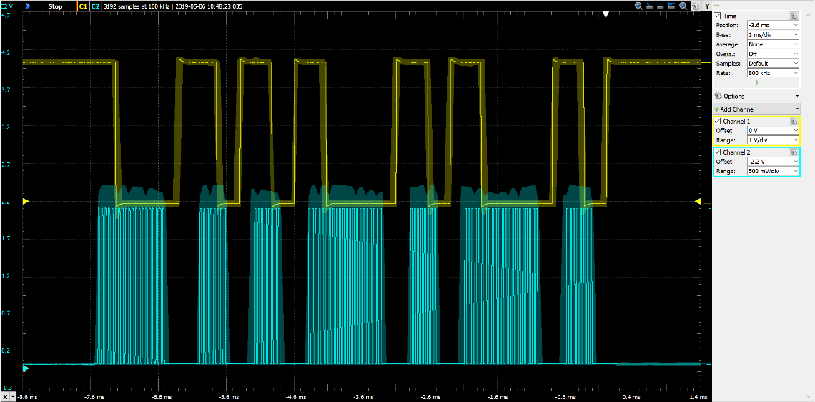

## *Address 0 Command 3*

# 

## *Address 0 Command 4*

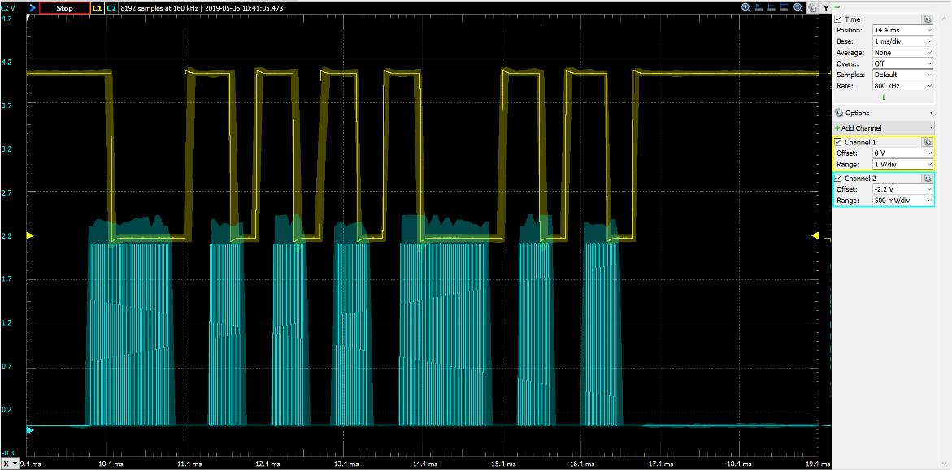

## *Address 0 Command 5*

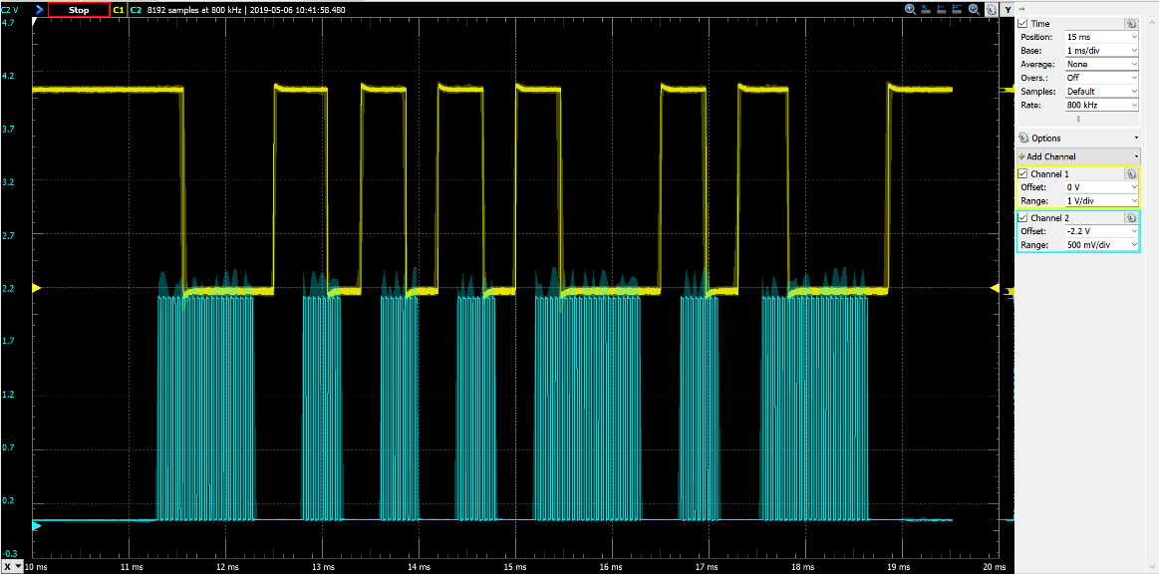

## *Address 0 Command 6*

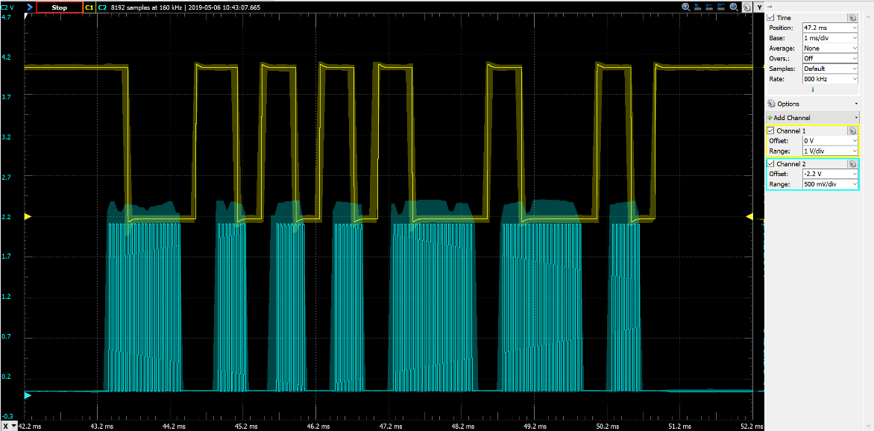

## *Address 0 Command 7*

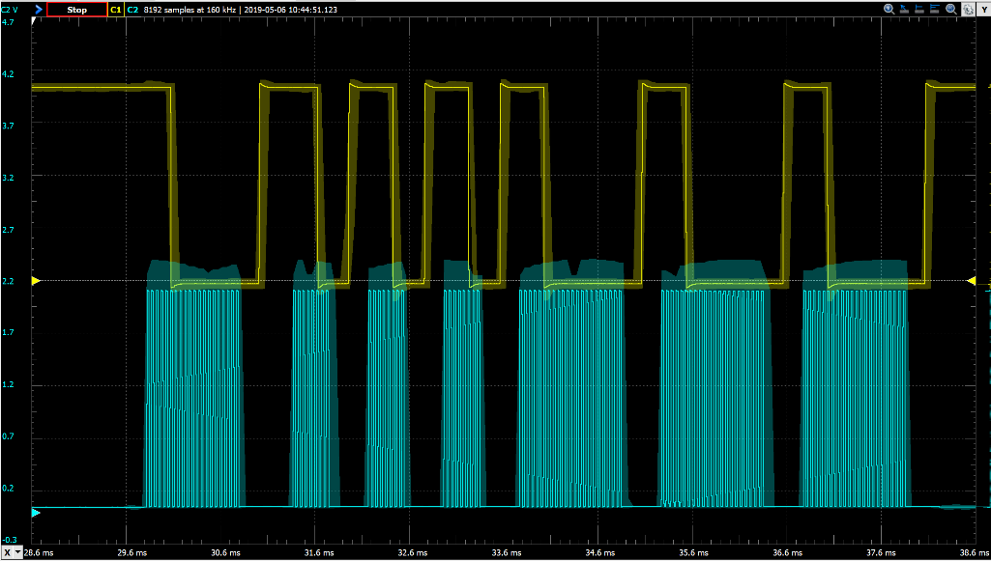

*Address 0 Command 8*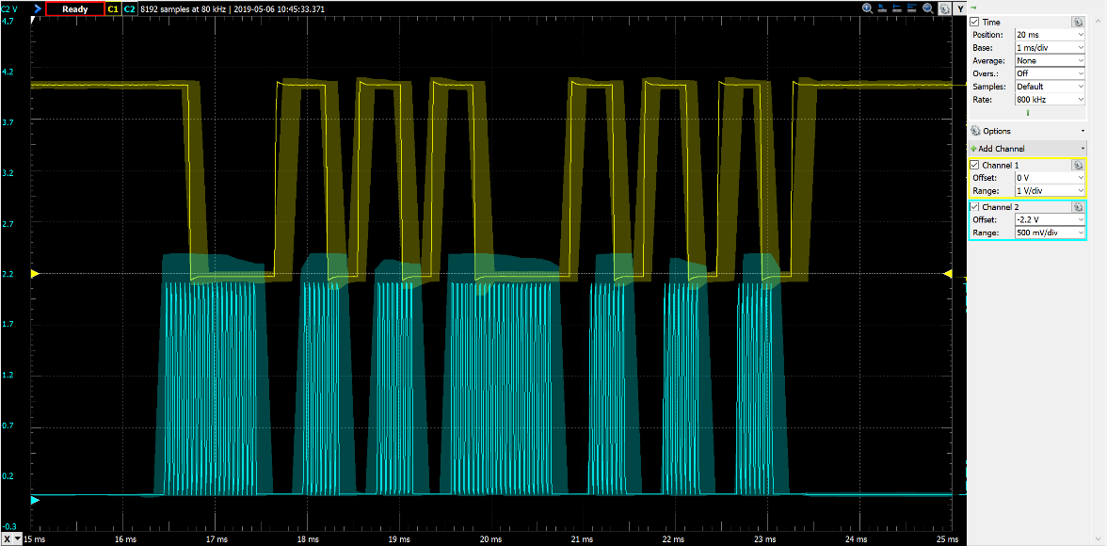

## *Address 0 Command 9*

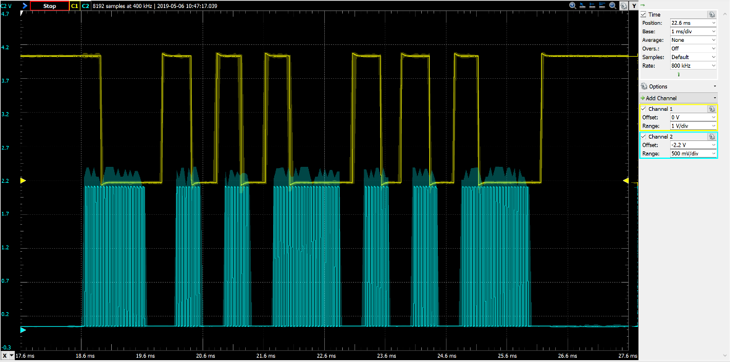

## *Address 0 Command A*

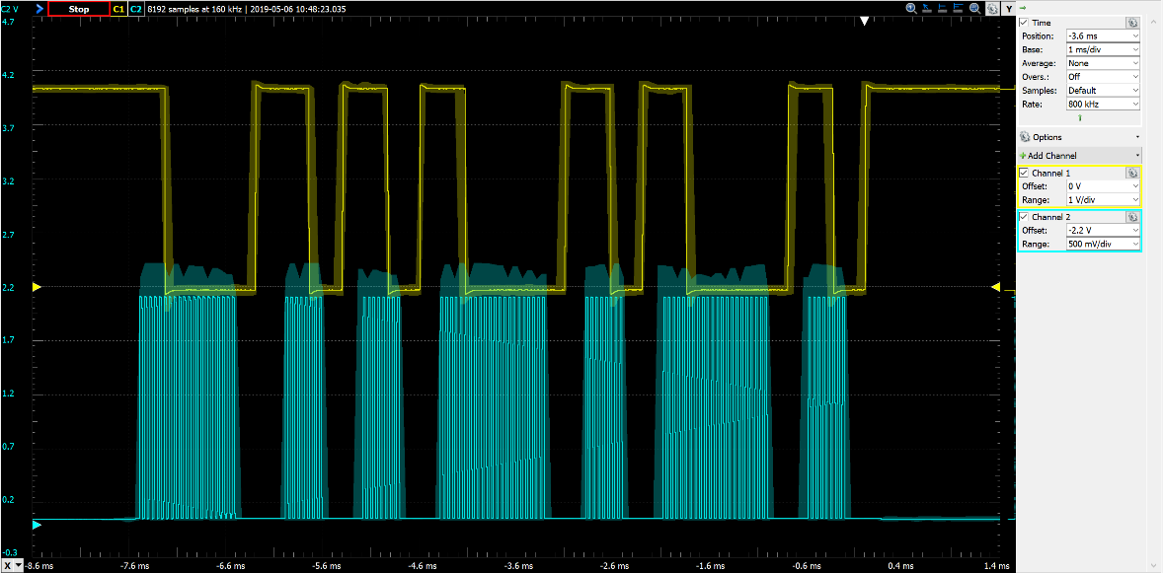

*Address 0 Command B*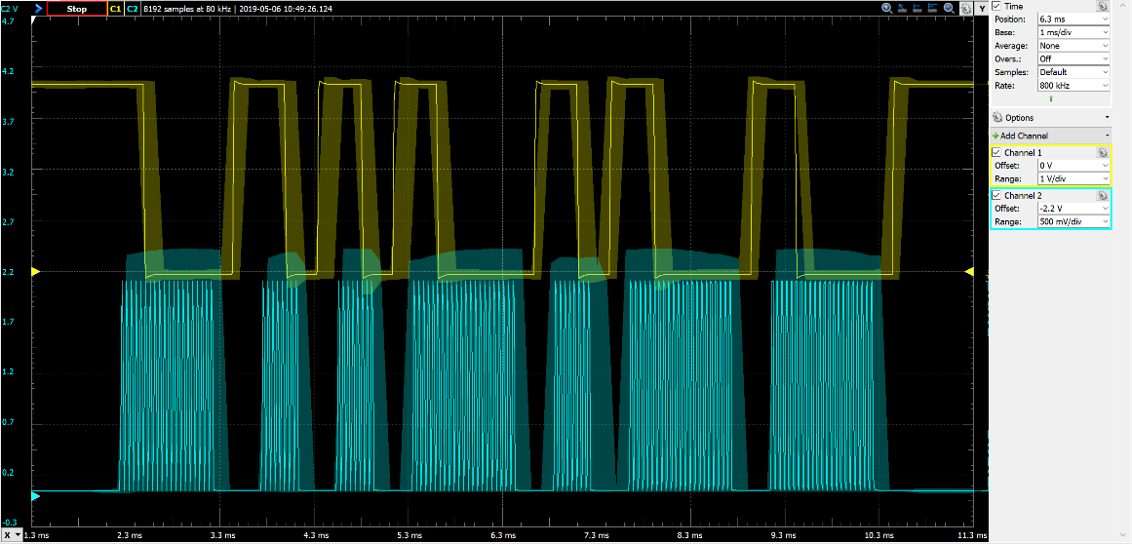

**Bluetooth Configuration mode**

## *Name Set up Slave mode set up*

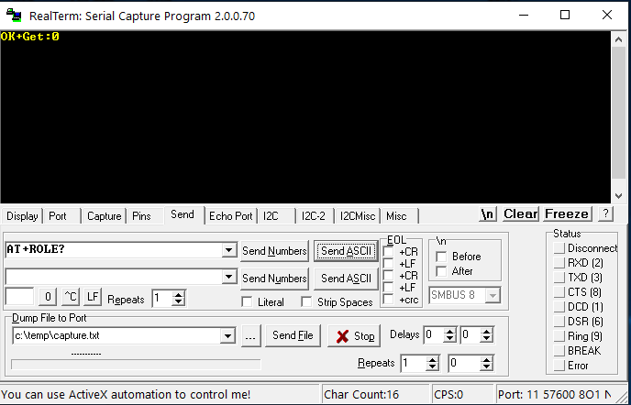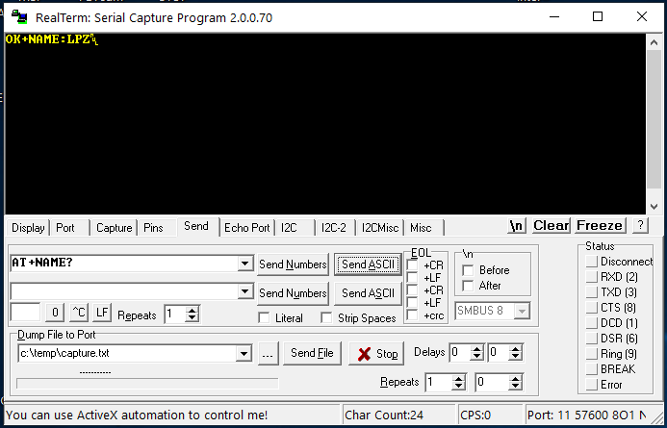

*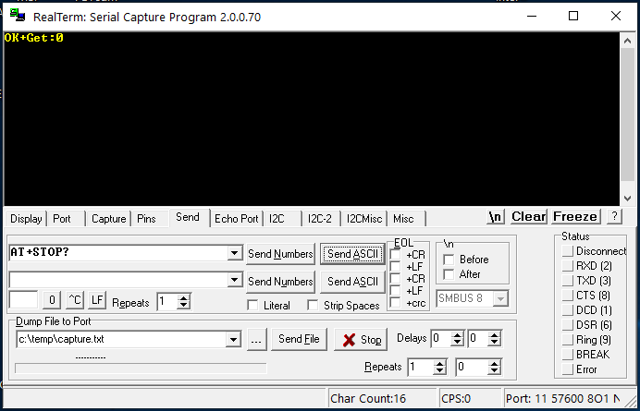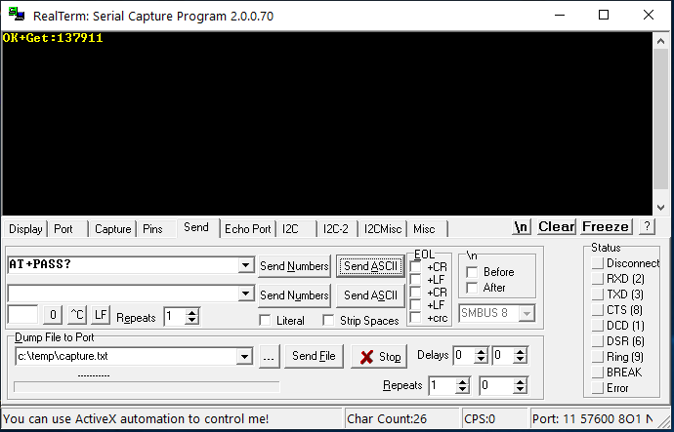Password set up* *Stop-bit set up*

*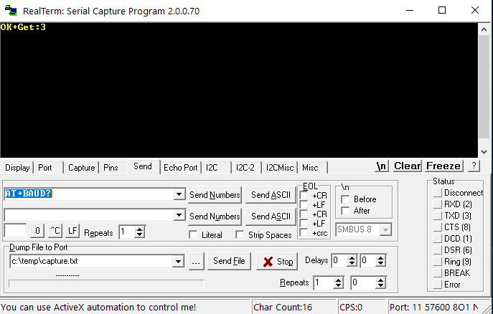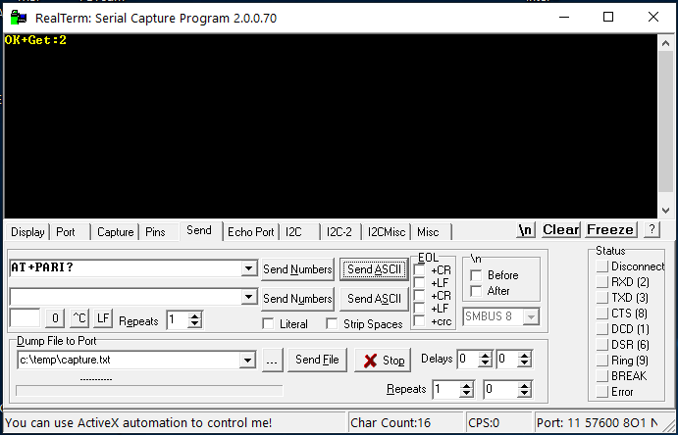Odd Parity set up* *Baud rate set up*

# **Conclusion**

Creating a new IR Protocol is a unique and challenging task. Working on this project gave us more inside of the benefits from using Oscilloscopes and working in a team since we divided the receiving and transmitting, but both sides had to work efficiently together to achieve the end goal, which was a new design Infrared protocol. For this project we learned the usefulness of PWM and timers to modulate signals, as the waveforms in the top prove it. UART was also very involved to communicate with the Bluetooth module and the receiver station with the 8-bit DAC Piano.

In this project, we learned the basics of the Digital to Analog Conversion (DAC). During this process, we learned the effect of wave frequencies with the help of timers. The 8-bit weighted DAC we created helped in sending 256 different analog signals coming from a digital device that did not have a DAC built in.  The different digital bits set at the input of the DAC created a variable voltage that we set for a specific amount of time which created wave frequency, then after repeating that we can transduce those frequencies to sound with the help of a speaker and an amplifier.

## **Source Code**

## *Transmitter Station*

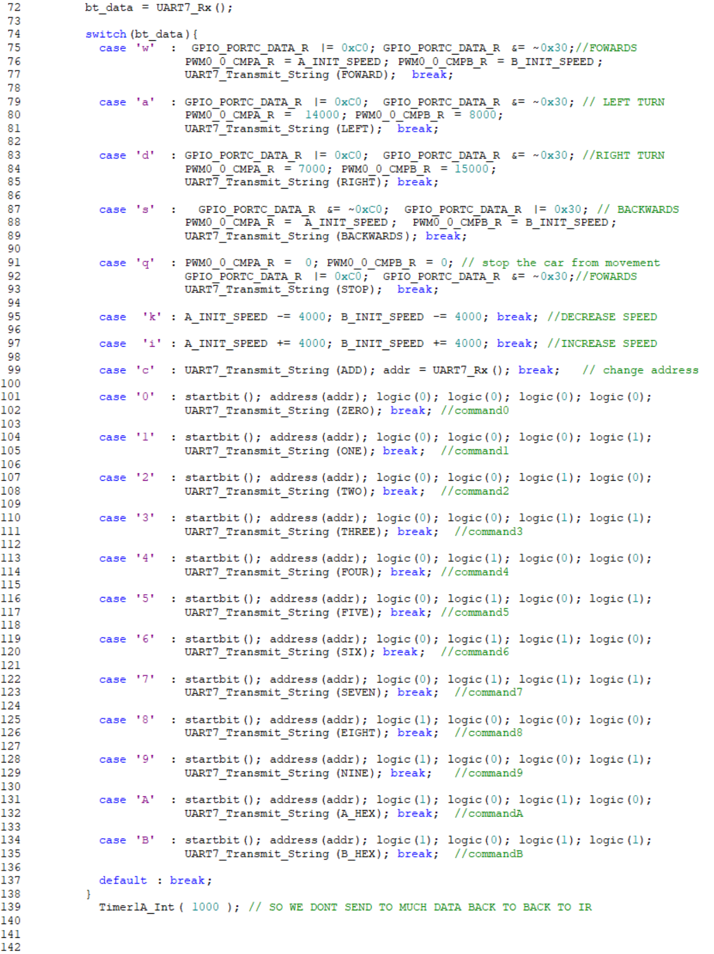

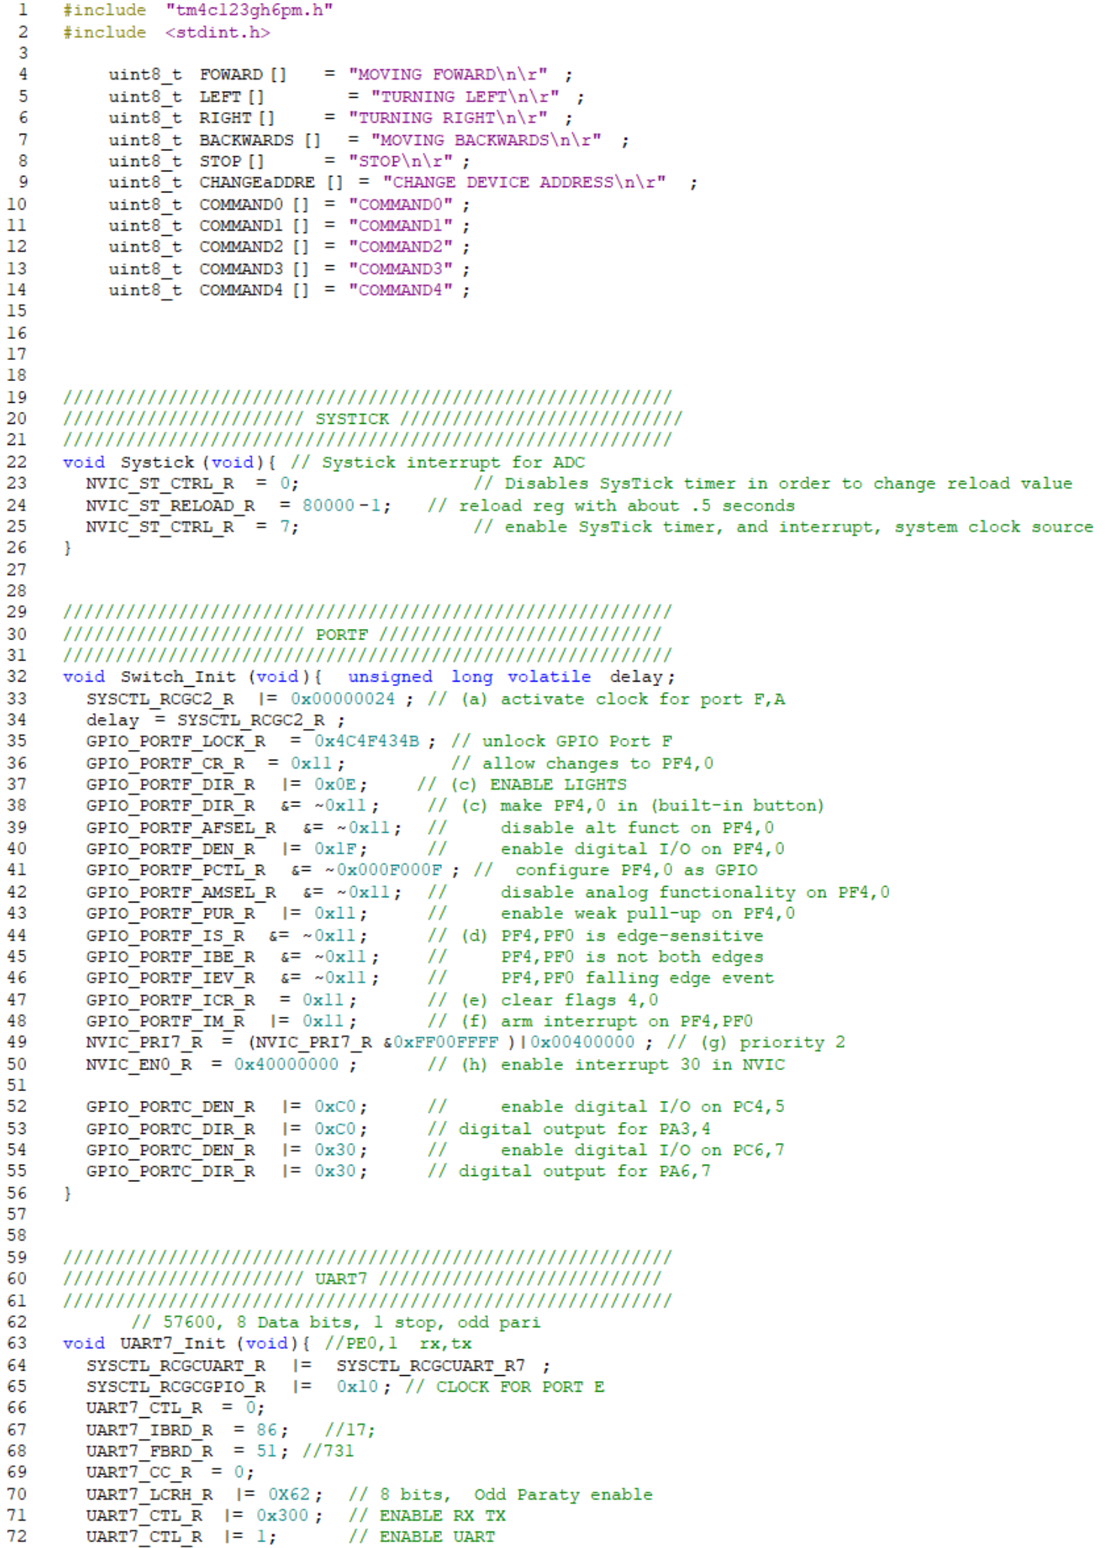

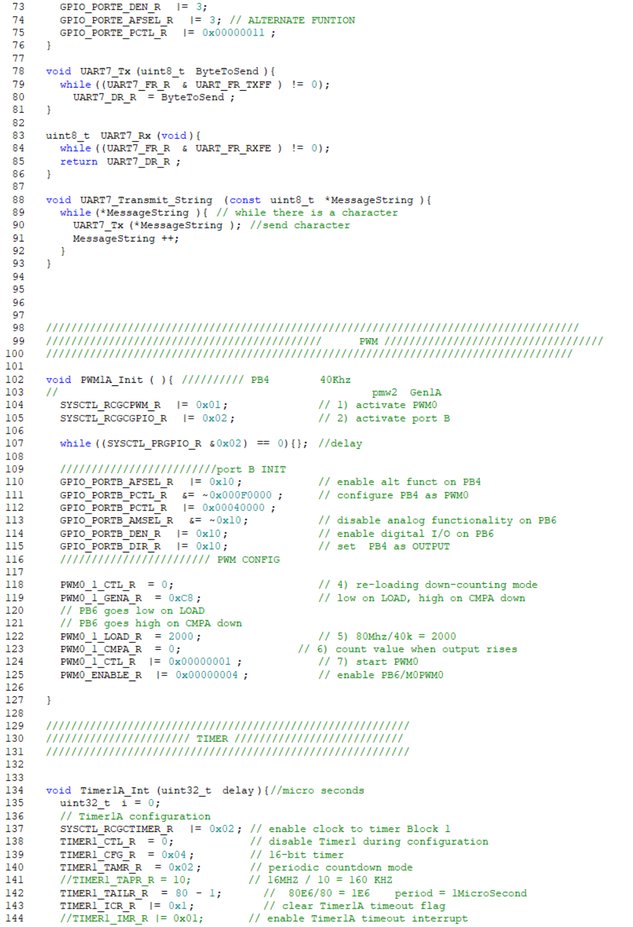

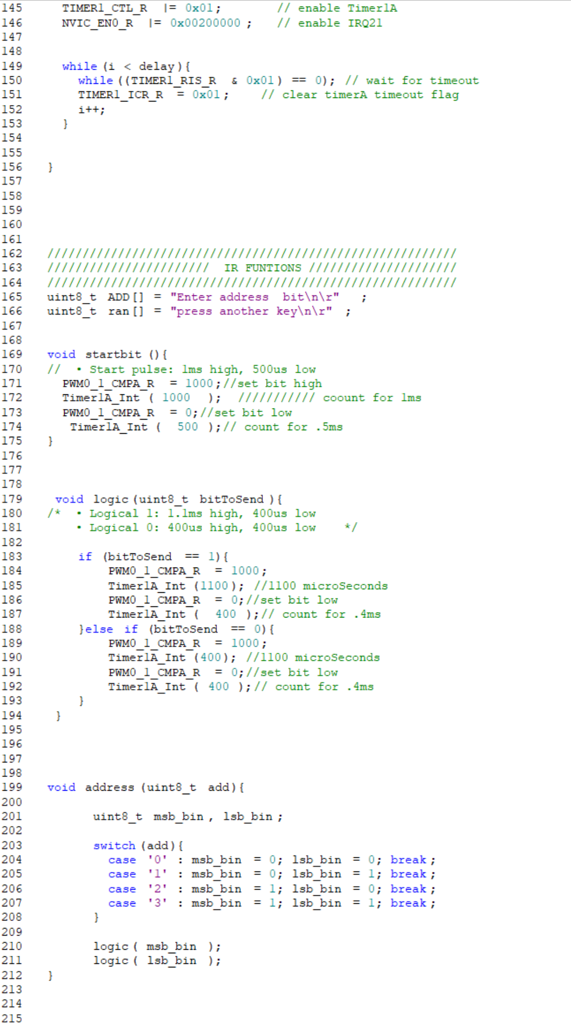

## *Receiver Station*

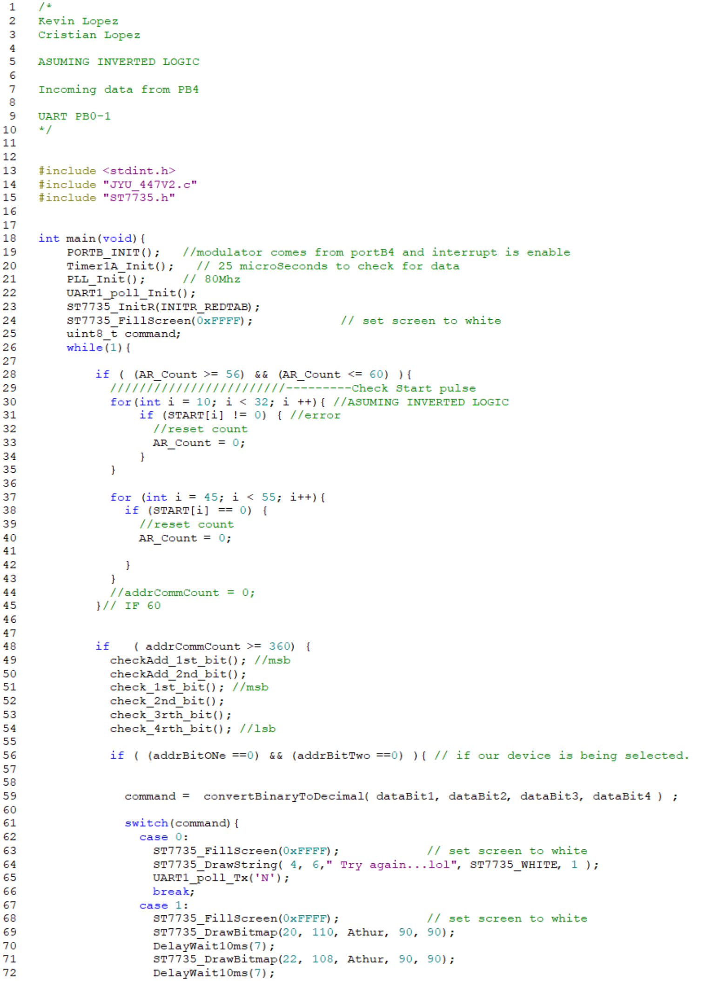

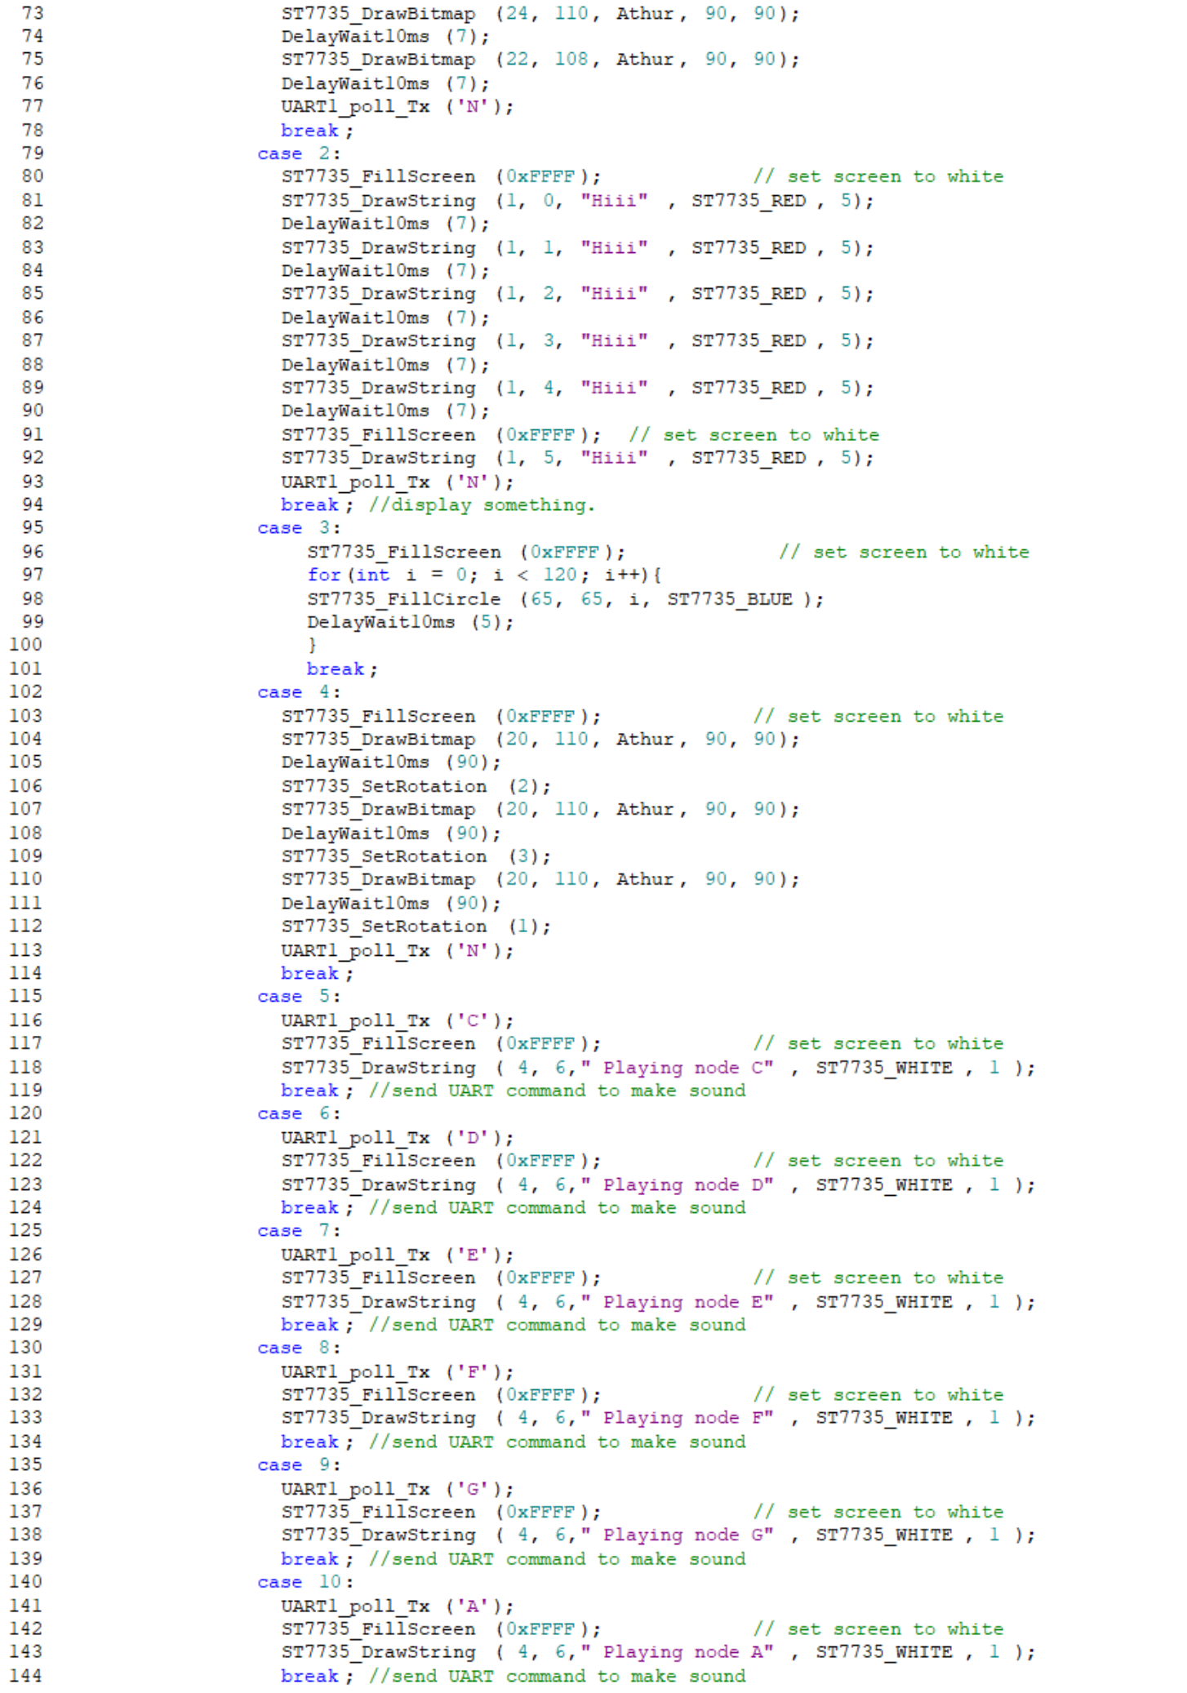

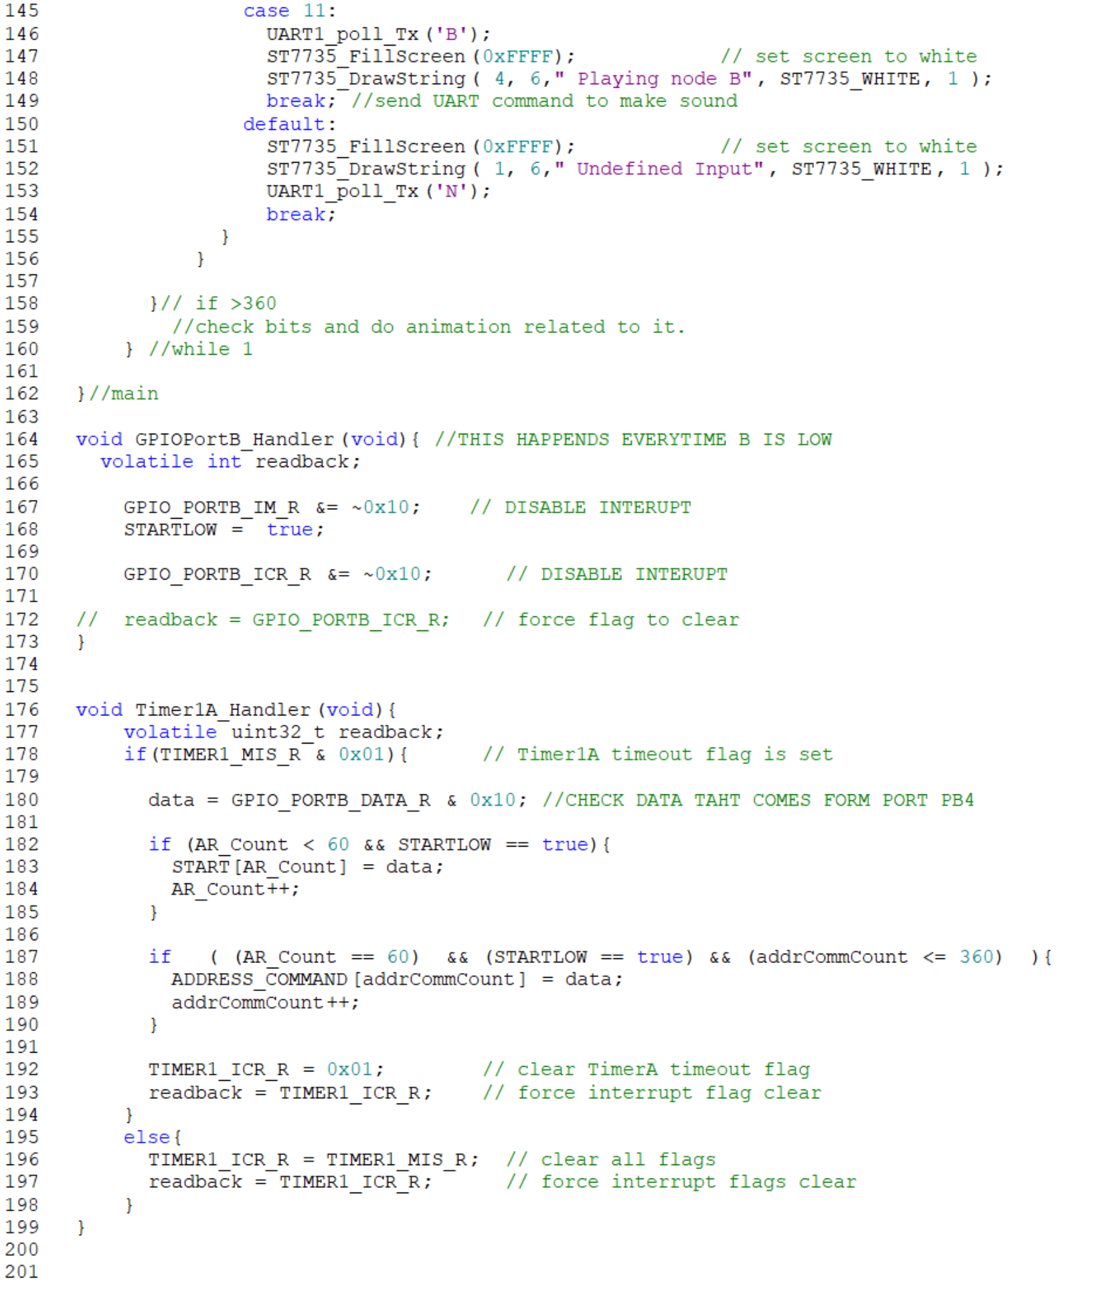

## *IR Protocol*

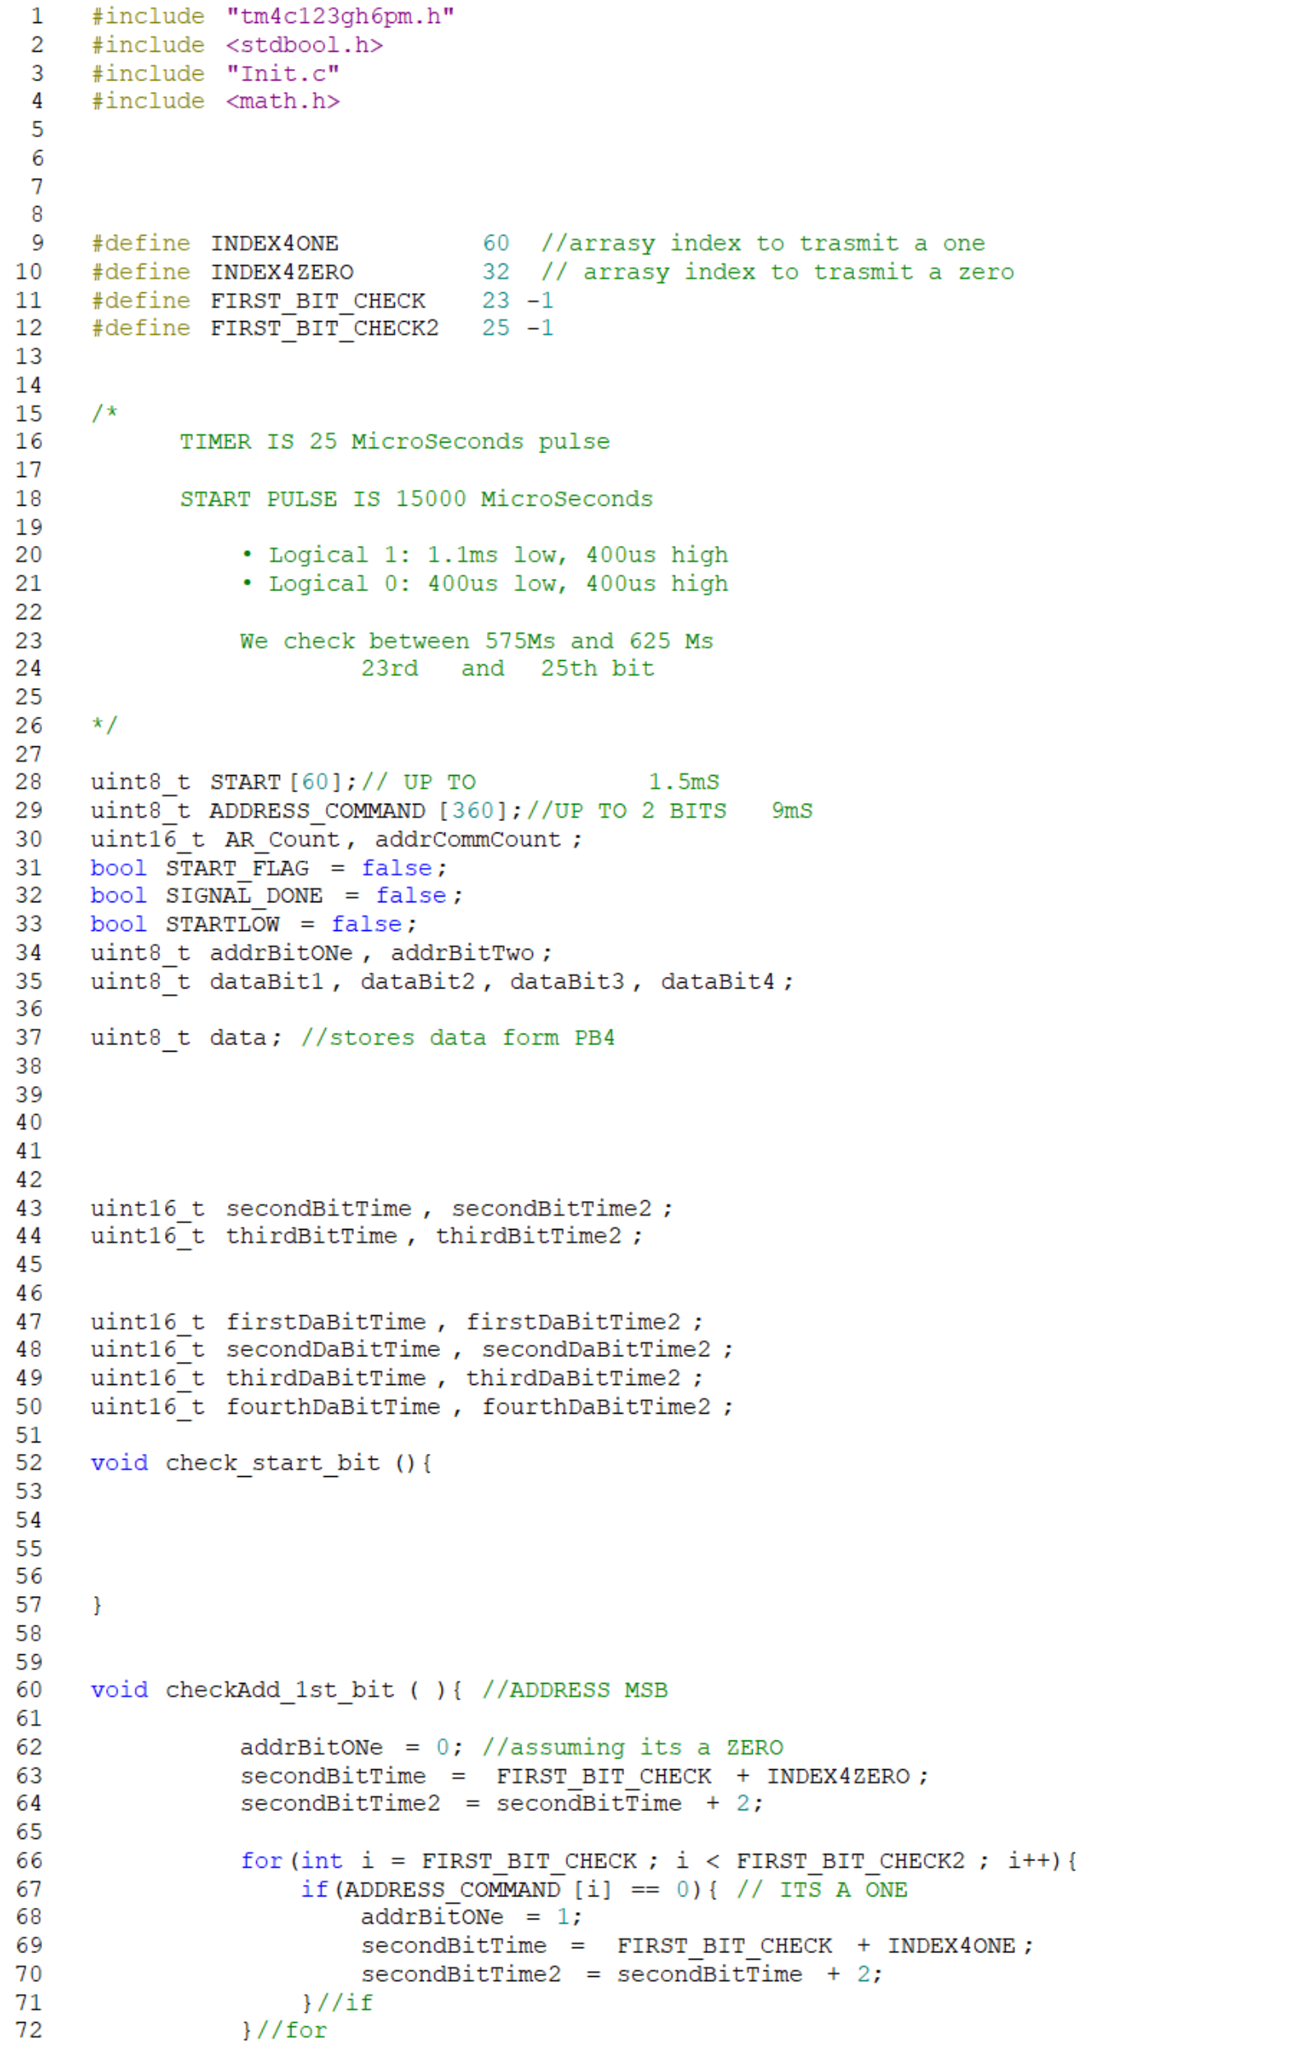

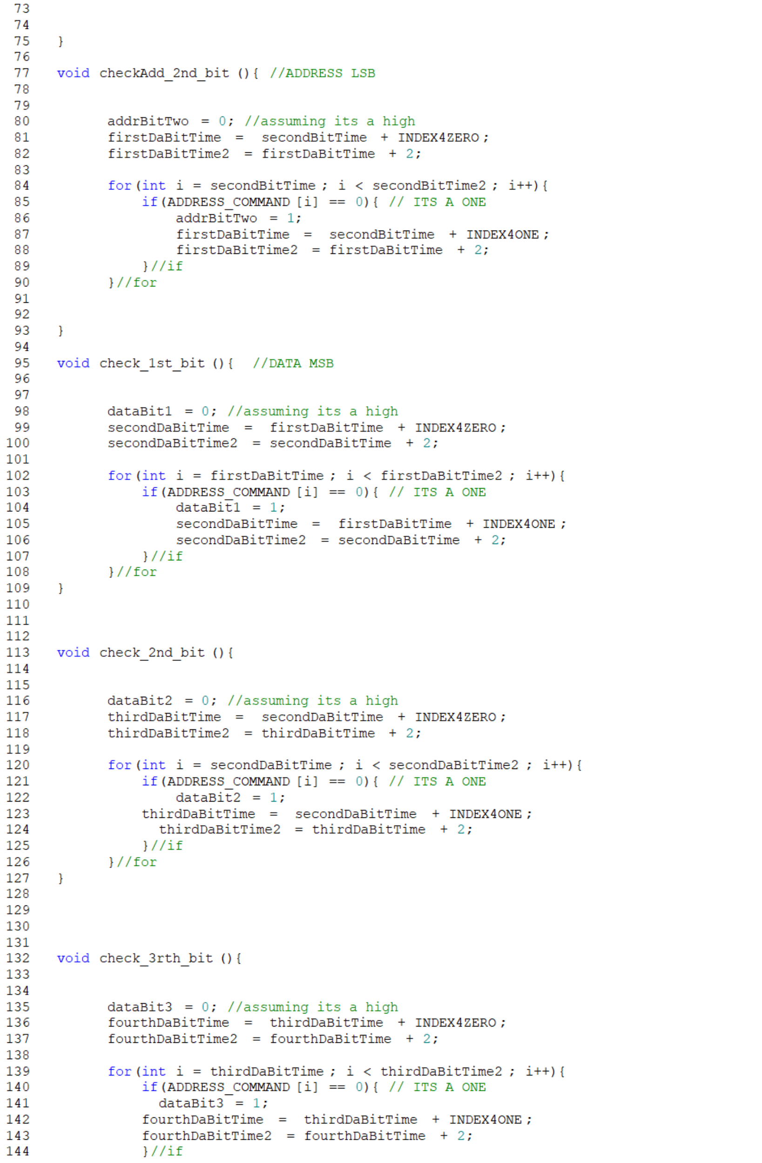

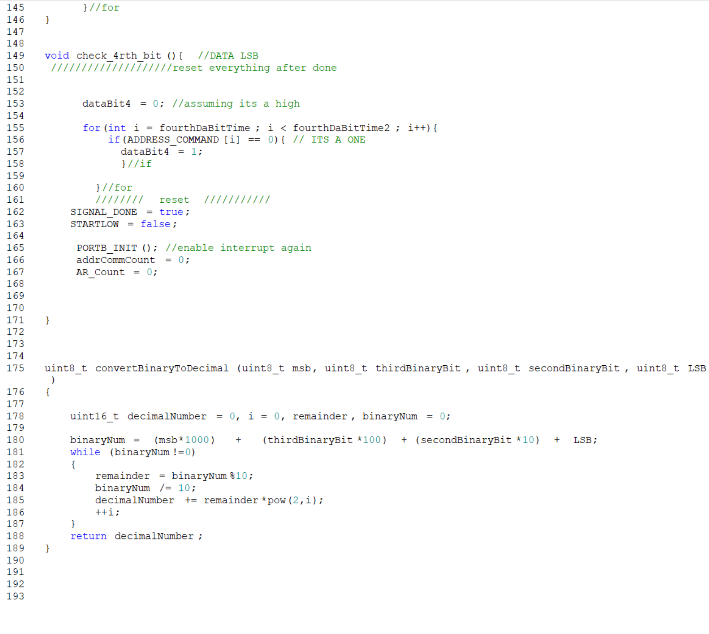

## Binary Weighted DAC Code

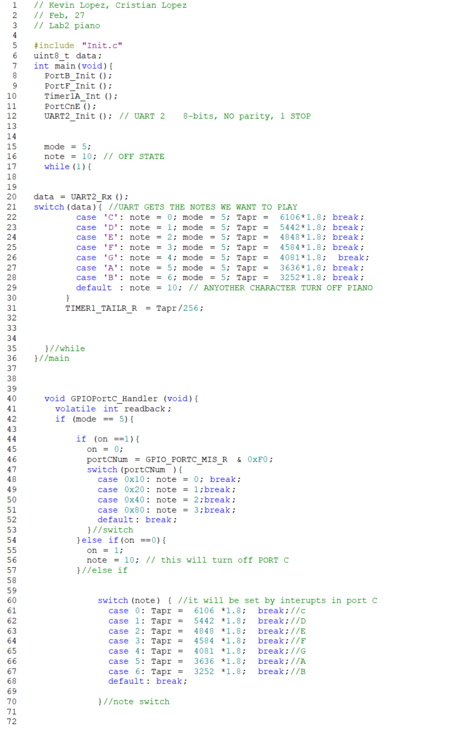

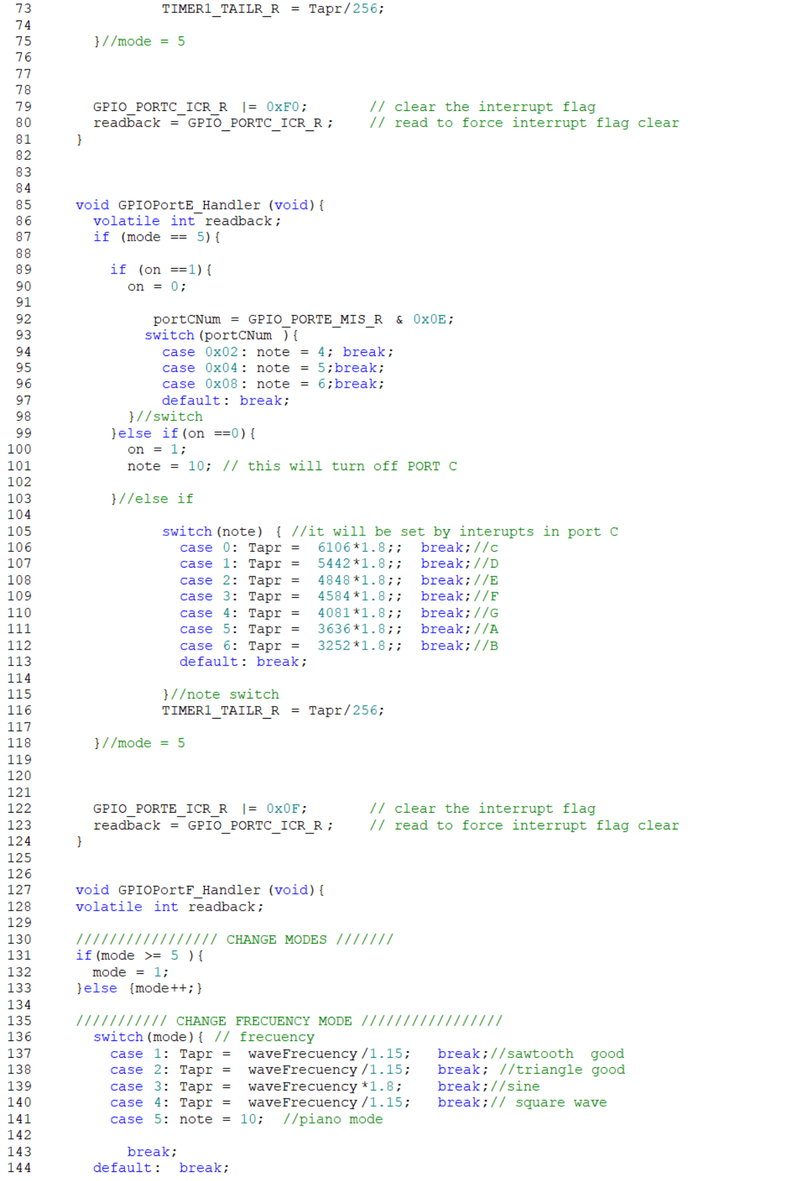

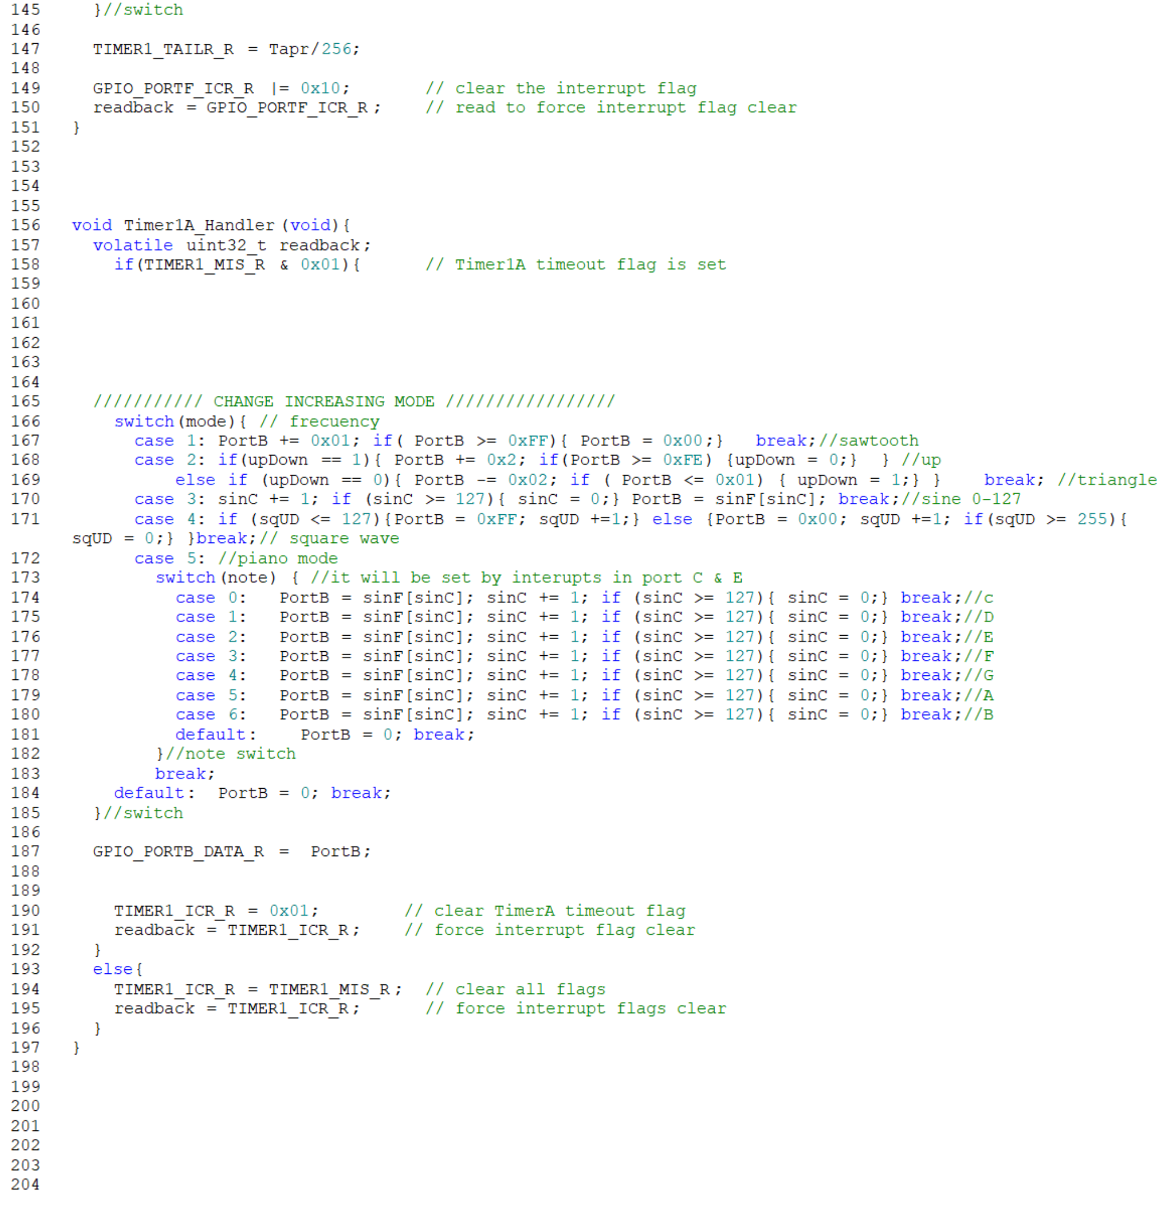

## *Initialization File*

